**LAPORAN PENGERJAAN UJI KOMPETENSI KEJURUAN**

**SMK MAHARDHIKA BATUJAJAR**

**TAHUN PELAJARAN 2022-2023**

|  |  |
| --- | --- |
| KOMPETENSI KEAHLIAN | :Rekayasa Perangkat Lunak |
| KELAS | :XII RPL 1 |
| NAMA LENGKAP | :Mochamad Rizal Seftian |
| NISN | :0044617683 |
| PAKET SOAL | :P2 |
| JENIS APLIKASI | :Website |
| ALOKASI WAKTU | :24 Jam |

# PENJADWALAN KEGIATAN

# PERSIAPAN PERANGKAT KERAS

# Laptop

# Ram:4GB

# Windows 10 64 bit

# Laptop Asus X456URK

# Keyboard

# Mouse

# Usb Port

# PERSIAPAN PERANGKAT LUNAK

# XAMPP

# Visual Code Studio

# Browser Chrome

# Astah

# Balsamiq

# PERANCANGAN ALGORITMA APLIKASI

# 

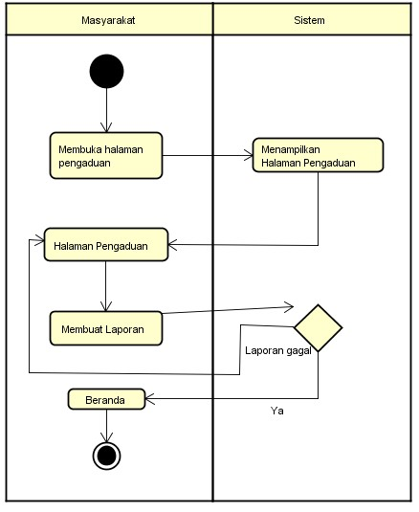

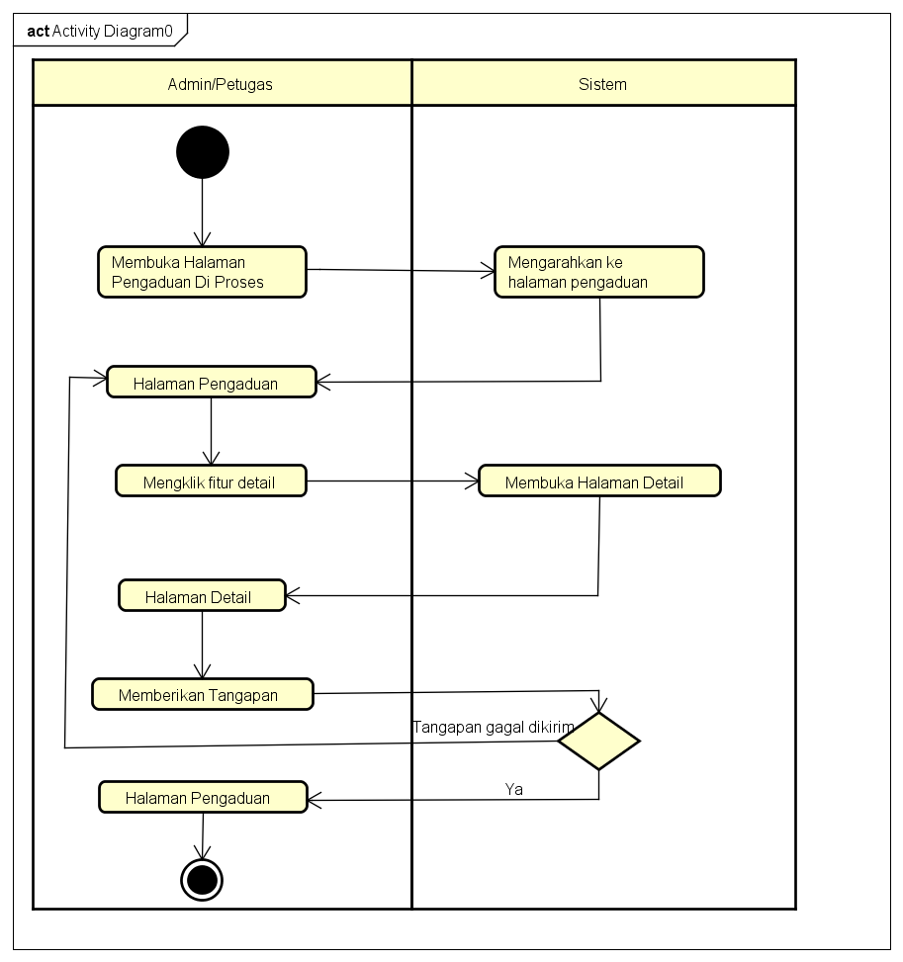

# PERANCANGAN DESAIN BASIS DATA

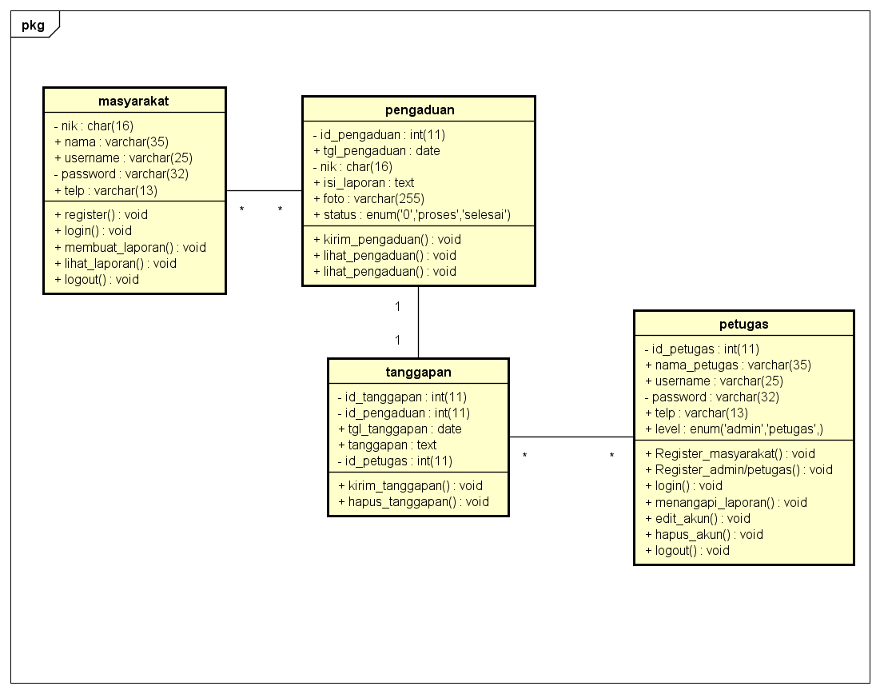

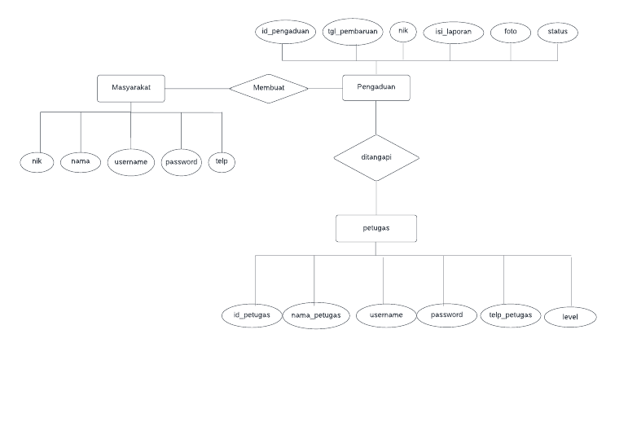

# DUMMY DATA

# Masyarakat

|  |  |  |  |  |
| --- | --- | --- | --- | --- |
| NIK | Nama | Username | Password | Telp |
| 312436656745 | Jack The Ripper | Jack | Jack231 | 089686668 |
| 31234455657 | Sasaki Kojiro | Kojiro | Kojiro568 | 089533352 |
| 3266788963 | Kasim Saepuloh | Kasim | Kasim123 | 08945345 |
| 7547574575 | Usep Sumpena | Usep | Usep089 | 08087445 |
| 38466564578 | Dede Sopandi | Dede | Dede45 | 086987667 |
| 646564789789 | Casemiro Emir | Emir | Emir57 | 089 67877 |

# Petugas

|  |  |  |  |  |  |
| --- | --- | --- | --- | --- | --- |
| **ID Petugas** | **Nama Petugas** | **Username** | **Password** | **Telepon** | **Level** |
| 0858676 | Gofar Samsih | Gofar | Gofar9867 | 0897661324 | Admin |
| 0942342 | Alif Komar | Alif | Alif54 | 085345554 | Admin |
| 0244434 | Leonidas | Leo | Leo98 | 095345345 | Petugas |
| 0321355 | Kratos | Kratos | Kratos45 | 054656655 | Petugas |
| 0532342 | Hades | Hades | Hades09 | 034234567 | Petugas |

# Pengaduan

|  |  |  |  |  |
| --- | --- | --- | --- | --- |
| **tgl_pengaduan** | **nik** | **isi_laporan** | **foto** | **Status** |
| Sesuaikan dengan hari pengaduan | 646564789789 | Jalan perlu diaspal dan dibenarkan agar menjadi nyaman | Bebas | Proses |
| Sesuaikan dengan hari pengaduan | 38466564578 | Perlu Ambulance desa untuk mengantar warga yang sakit | Bebas | Proses |
| Sesuaikan dengan hari pengaduan | 3266788963 | Got air sering tersumbat perlu penanganan | Bebas | Proses |
| Sesuaikan dengan hari pengaduan | 3266788963 | Banyak remaja mabuk,mohon melakukan pengamanan | Bebas | Proses |
| Sesuaikan dengan hari pengaduan | 3266788963 | Banyaknya pencurian mohon ditingkatkan keamanan | Bebas | Proses |

# PEMBUATAN BASIS DATA (MySQL Code)

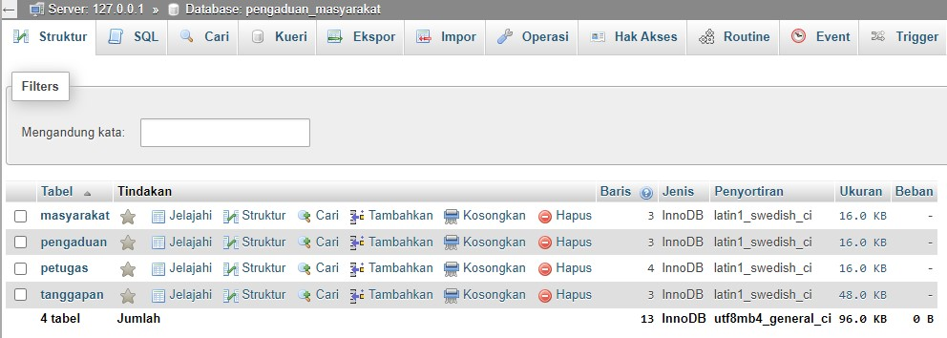

# PERANCANGAN TAMPILAN ANTARMUKA (UI) WEB

* + **Aplikasi pengaduan masyarakat**

1. *Silahkan gambarkan use case diagram aplikasi yang kamu buat*

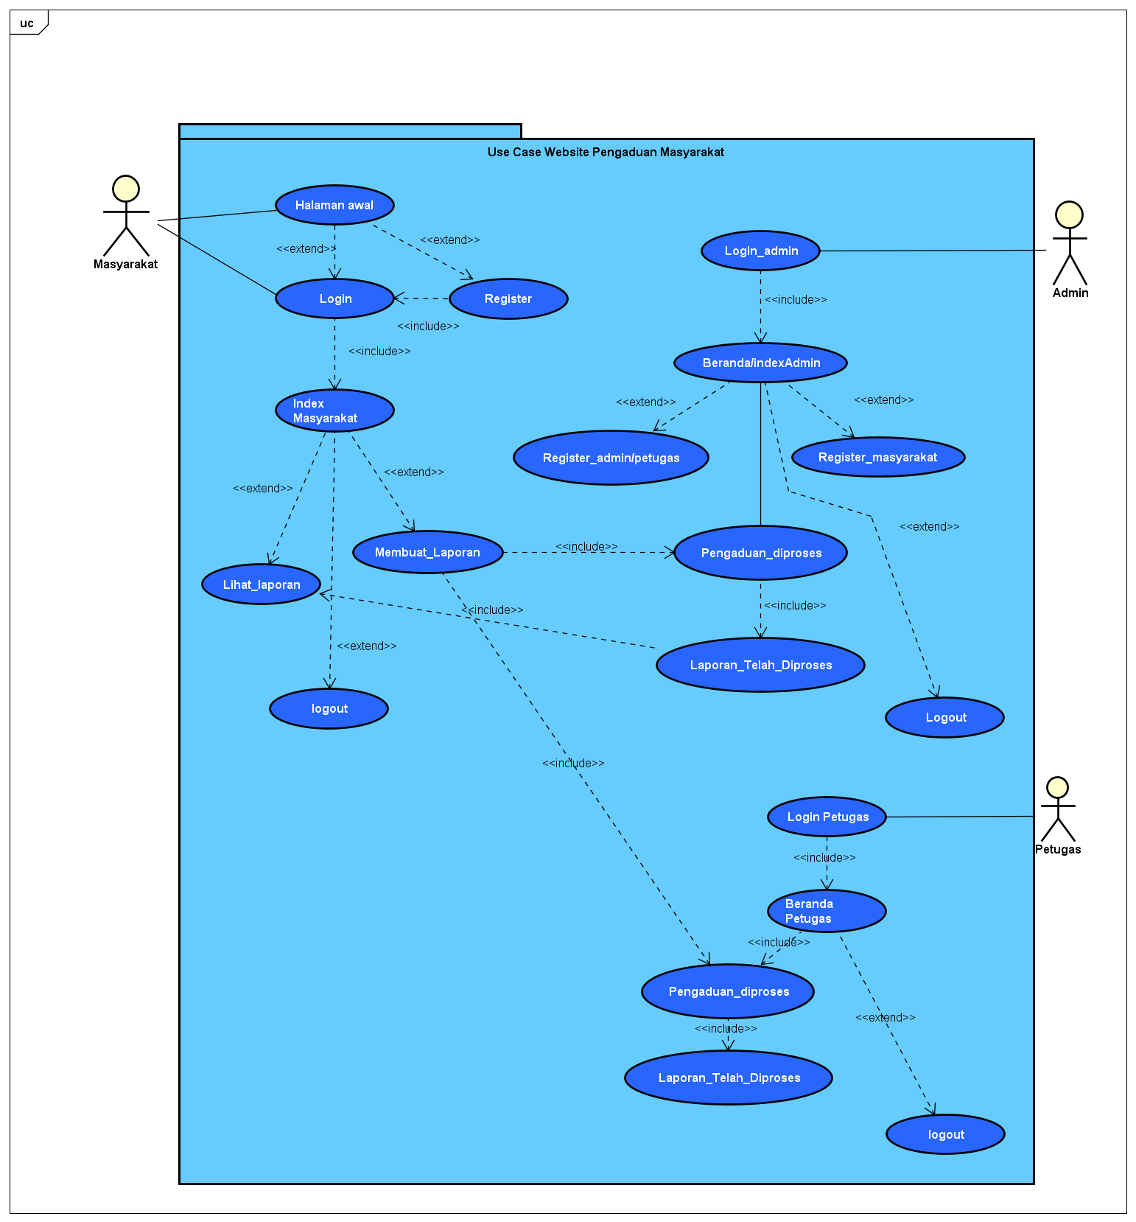

1. Admin dashboard

Tampilan untuk full manage semua data, buatkan sketsa/mockup-nya

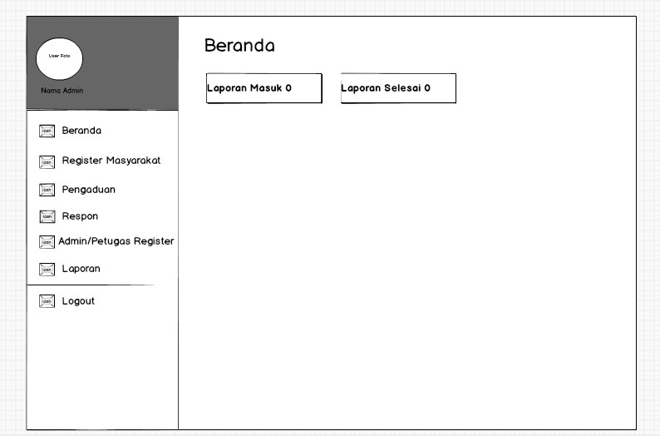

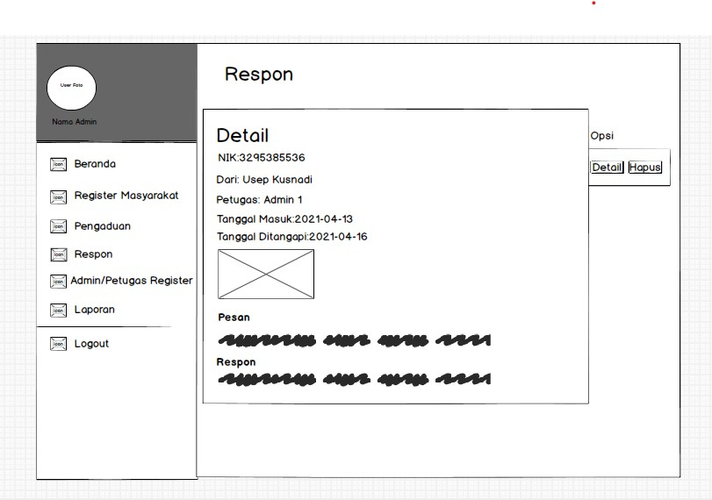

1. Tampilan Petugas

buatkan sketsa/mockup-nya

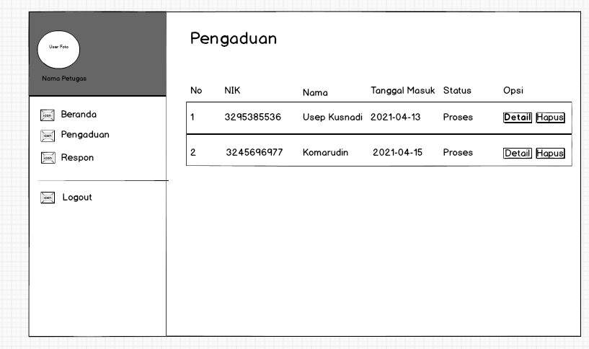

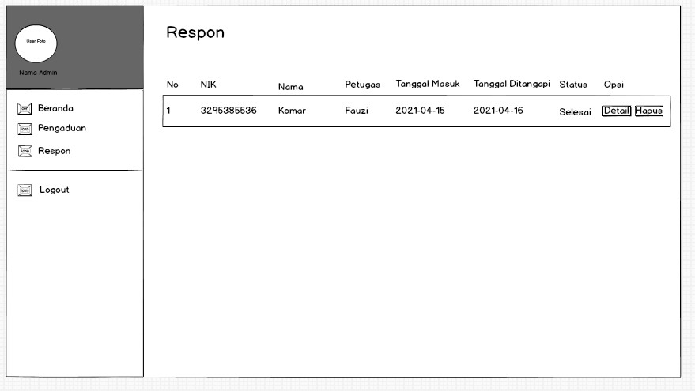

1. Tampilan masyarakat

Dashboard,about,tambah laporan,daftar komentar, tanggapan, buatkan sketsa/mockup-nya

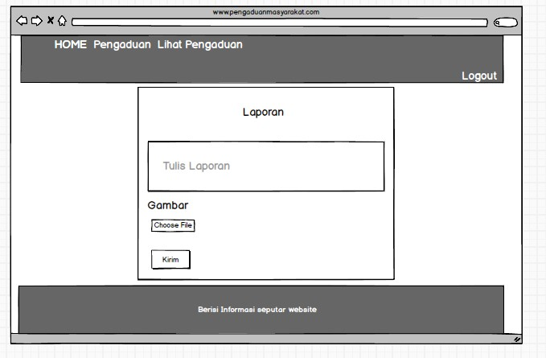

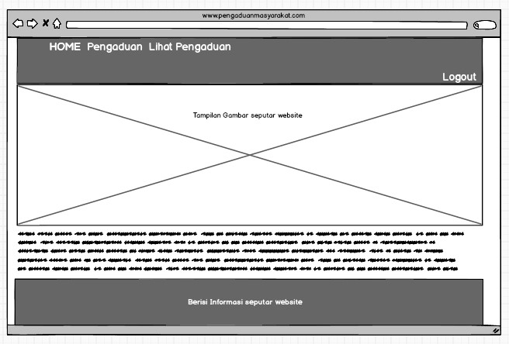

# PEMBUATAN STYLE WEB (CSS)

|  |
| --- |
| body {height:100%;font-family: sans-serif;background-color: #F5F5F5;padding-top: 45px;margin: 0.5% 5%;}html {height: 100%;}.item img {width: 100%;}/* Custom Navbar Toggle */@media (max-width: 938px) {.navbar-header {float: none;}.navbar-left,.navbar-right {float: none !important;}.navbar-toggle {display: block;}.navbar-collapse {border-top: 1px solid transparent;box-shadow: inset 0 1px 0 rgba(255,255,255,0.1);}.navbar-fixed-top {top: 0;border-width: 0 0 1px;}.navbar-collapse.collapse {display: none!important;}.navbar-nav {float: none!important;margin-top: 7.5px;}.navbar-nav>li {float: none;}.navbar-nav>li>a {padding-top: 10px;padding-bottom: 10px;}.collapse.in{display:block !important;}}/* End Custom Navbar Toggle */.shadow {box-shadow: 0px 4px 8px #888888;border-radius: 5px;min-height: 100%;}.footer {padding-top: 3rem;padding-bottom: 2rem;background-color: #263238;color: #fff;bottom: 0;box-shadow: 0px 1px 12px #888888;}.footer-bottom {margin-top: 15%;}.copyright {background-color: #1a252f;border-bottom-left-radius: 5px;border-bottom-right-radius: 5px;bottom: 0;}.py-4 {padding-top: 1.5rem!important;padding-bottom: 1.5rem!important;}.position-fixed {position: fixed!important;}.text-white {color: #fff!important;}.main-content {padding: 12px;}.btn-social {width: 3.8rem;height: 3.5rem;font-size: 1.5rem;line-height: 2rem;color: #fff;}.btn-social:hover {color: #18bc9c;}.text-center {text-align: center!important;}.rounded-circle {border-radius: 50%!important;}.btn-outline-light {color: #f8f9fa;background-color: transparent;background-image: none;border-color: #f8f9fa;}.fa-top {font-size: 1.3em;}.img-cara {margin-bottom: 12px;min-width: 350px;min-height: 200px;}@media (max-width: 500px) {.img-cara {margin-bottom: 12px;max-width: 200px;max-height: 150px;}}.map {width: 50%;height: 300px;}.nav-link a{font-size: 14px;color: #000;}.box {border-radius: 3px;box-shadow: 0 2px 5px 0 rgba(0, 0, 0, 0.16), 0 2px 10px 0 rgba(0, 0, 0, 0.12);padding: 10px 25px;display: block;margin-top: 32px;margin-bottom: 18px;}/* social feed home */.social-feed {margin: auto 2%;}.box-icon {background-color: #00897b;border-radius: 50%;display: table;height: 50px;margin: 0 auto;width: 50px;margin-top: -37px;}.box-icon span {color: #fff;display: table-cell;text-align: center;vertical-align: middle;}.info h4 {font-size: 26px;letter-spacing: 2px;}.info > p {color: #717171;font-size: 16px;padding-top: 10px;text-align: justify;}.info > a {background-color: #03a9f4;border-radius: 2px;box-shadow: 0 2px 5px 0 rgba(0, 0, 0, 0.16), 0 2px 10px 0 rgba(0, 0, 0, 0.12);color: #fff;transition: all 0.5s ease 0s;}.info > a:hover {background-color: #0288d1;box-shadow: 0 2px 3px 0 rgba(0, 0, 0, 0.16), 0 2px 5px 0 rgba(0, 0, 0, 0.12);color: #fff;transition: all 0.5s ease 0s;}.fb-page,.fb-page span,.fb-page span iframe[style] {width: 100% !important;padding-bottom: 4px;}.item:after {content:"";display:block;position:absolute;top:0;bottom:0;left:0;right:0;background:rgba(0,0,0,0.3);}@media screen and (min-width: 1000px) {.welcome {margin-bottom: 13%;}}.form-shadow {box-shadow: 0px 0px 4px #888888;border-radius: 2px;}.form-custom {margin: 0px 16px;padding: 16px 16px 1px 8px;}.navbar-fixed {position: fixed;top: 0;left: 0;right: 0;z-index: 20;margin: 0 5%;box-shadow: 0px 0px 4px #888888;}.custom-line {border-color: #263238;border-width: 2px;max-width: 25%;}/* css untuk lihat */.panel-body {/* padding: 25px 20px; */margin-top: 14px;}.panel-body h4 {margin-top: 0px;}.hr-laporan {margin-top: 0px;margin-bottom: 12px;}.media-block .media-left {display: block;float: left}.media-block .media-body {display: block;overflow: hidden;width: auto;}.isi-laporan{padding-right: 8px;}.comment {background-color: #EEEEEE;padding: 8px 8px 0px 8px;border-radius: 4px;}.img-sm {width: 46px;height: 46px;}.text-muted, a.text-muted:hover, a.text-muted:focus {color: #acacac;}.text-sm {font-size: 0.9em;}/* card pengaduan home */.card-shadow {box-shadow: 0px 1px 7px #888888;border-radius: 5px; } |

# PEMBUATAN KODE WEB (PHP/JS)

# Index.php (Index Admin)

|  |
| --- |
| <?phpsession_start();include '../conn/koneksi.php';if(!isset($_SESSION['username'])){header('location:../index.php');}elseif($_SESSION['data']['level'] != "admin"){header('location:../index.php');}?><!DOCTYPE html><html><head><title>Aplikasi Pengaduan masyarakat</title><link rel="icon" href="../img/icon.jpg"><!--Import Google Icon Font--><link href="https://fonts.googleapis.com/icon?family=Material+Icons" rel="stylesheet"><!--Import materialize.css--><link type="text/css" rel="stylesheet" href="../css/materialize.min.css" media="screen,projection"/><!-- Compiled and minified CSS --><link rel="stylesheet" href="https://cdnjs.cloudflare.com/ajax/libs/materialize/1.0.0/css/materialize.min.css"><!-- Compiled and minified JavaScript --><script src="https://cdnjs.cloudflare.com/ajax/libs/materialize/1.0.0/js/materialize.min.js"></script><script src="https://ajax.googleapis.com/ajax/libs/jquery/3.4.1/jquery.min.js"></script><!--Let browser know website is optimized for mobile--><meta name="viewport" content="width=device-width, initial-scale=1.0"/><link rel="stylesheet" type="text/css" href="https://cdn.datatables.net/1.10.19/css/jquery.dataTables.css"><script src="https://ajax.googleapis.com/ajax/libs/jquery/3.4.1/jquery.min.js"></script><script type="text/javascript" charset="utf8" src="https://cdn.datatables.net/1.10.19/js/jquery.dataTables.js"></script><script type="text/javascript">$(document).ready( function () {$('#example').DataTable();$('select').formSelect();} );</script></head><body style="background:url(../img/adminbg.jpg); background-size: cover;"><div class="row"><div class="col s12 m3"><ul id="slide-out" class="sidenav sidenav-fixed"><li><div class="user-view"><div class="background"><img src="../img/bggray.jpg"></div><a href="#user"><img class="circle" src="../img/avataruser.jpg"></a><a href="#name"><span class="white-text name"><?php echo ucwords($_SESSION['data']['nama_petugas']); ?></span></a></div></li><li><a href="index.php?p=dashboard"><i class="material-icons">home</i>Beranda</a></li><li><a href="index.php?p=registrasi"><i class="material-icons">featured_play_list</i>Registrasi Masyarakat</a></li><li><a href="index.php?p=pengaduan"><i class="material-icons">report</i>Pengaduanz DiProses</a></li><li><a href="index.php?p=respon"><i class="material-icons">question_answer</i>Laporan Telah Direspon</a></li><li><a href="index.php?p=user"><i class="material-icons">account_box</i>Registrasi Admin/Staff</a></li><li><a href="index.php?p=laporan"><i class="material-icons">book</i>Laporan</a></li><li><div class="divider"></div></li><li><a class="waves-effect" href="../index.php?p=logout"><i class="material-icons">logout</i>Logout</a></li></ul><a href="#" data-target="slide-out" class="btn sidenav-trigger"><i class="material-icons">menu</i></a></div><div class="col s12 m9"><?phpif(@$_GET['p']==""){include_once 'dashboard.php';}elseif(@$_GET['p']=="dashboard"){include_once 'dashboard.php';}elseif(@$_GET['p']=="registrasi"){include_once 'registrasi.php';}elseif(@$_GET['p']=="regis_hapus"){$query = mysqli_query($koneksi,"DELETE FROM masyarakat WHERE nik='".$_GET['nik']."'");if($query){header('location:index.php?p=registrasi');}}elseif(@$_GET['p']=="pengaduan"){include_once 'pengaduan.php';}elseif(@$_GET['p']=="pengaduan_hapus"){$query=mysqli_query($koneksi,"SELECT * FROM pengaduan WHERE id_pengaduan='".$_GET['id_pengaduan']."'");$data=mysqli_fetch_assoc($query);unlink('../img/'.$data['foto']);if($data['status']=="proses"){$delete=mysqli_query($koneksi,"DELETE FROM pengaduan WHERE id_pengaduan='".$_GET['id_pengaduan']."'");header('location:index.php?p=pengaduan');}elseif($data['status']=="selesai"){$delete=mysqli_query($koneksi,"DELETE FROM pengaduan WHERE id_pengaduan='".$_GET['id_pengaduan']."'");if($delete){$delete2=mysqli_query($koneksi,"DELETE FROM tanggapan WHERE id_pengaduan='".$_GET['id_pengaduan']."'");header('location:index.php?p=pengaduan');}}}elseif(@$_GET['p']=="more"){include_once 'more.php';}elseif(@$_GET['p']=="respon"){include_once 'respon.php';}elseif(@$_GET['p']=="tanggapan_hapus"){$query = mysqli_query($koneksi,"DELETE FROM tanggapan WHERE id_tanggapan='".$_GET['id_tanggapan']."'");if($query){header('location:index.php?p=respon');}}elseif(@$_GET['p']=="user"){include_once 'user.php';}elseif(@$_GET['p']=="user_input"){include_once 'user_input.php';}elseif(@$_GET['p']=="user_edit"){include_once 'user_edit.php';}elseif(@$_GET['p']=="user_hapus"){$query = mysqli_query($koneksi,"DELETE FROM petugas WHERE id_petugas='".$_GET['id_petugas']."'");if($query){header('location:index.php?p=user');}}elseif(@$_GET['p']=="laporan"){include_once 'laporan.php';}?></div></div><!--JavaScript at end of body for optimized loading--><script type="text/javascript" src="../js/materialize.min.js"></script><script type="text/javascript" src="https://cdnjs.cloudflare.com/ajax/libs/materialize/1.0.0/js/materialize.min.js"></script><script type="text/javascript">document.addEventListener('DOMContentLoaded', function() {var elems = document.querySelectorAll('.sidenav');var instances = M.Sidenav.init(elems);});document.addEventListener('DOMContentLoaded', function() {var elems = document.querySelectorAll('.modal');var instances = M.Modal.init(elems);});</script></body></html> |

# Koneksi.php

|  |
| --- |
| <?php $koneksi=mysqli_connect("localhost","root","","pengaduan_masyarakat"); ?> |

# Crud File

|  |
| --- |
| <?phpsession_start();error_reporting(0);include '../conn/koneksi.php';if(!isset($_SESSION['username'])){header('location:../index.php');}elseif($_SESSION['level'] != "masyarakat"){header('location:../index.php');}?><!DOCTYPE html><html><head><link rel="icon" href="../img/icon.jpg"><title>Halaman membuat laporan</title><meta charset="utf-8"><meta name="viewport" content="width=device-width"><link rel="shortcut icon" href="images/favicon.ico"><!-- Bootstrap CSS --><link rel="stylesheet" href="../css/bootstrap.css"><!-- font Awesome CSS --><link rel="stylesheet" href="../css/font-awesome.min.css"><!-- Main Styles CSS --><link href="../css/style.css" rel="stylesheet"><!-- jQuery --><script src="../js/jquery.min.js"></script><!-- Bootstrap JavaScript --><script src="../js/bootstrap.js"></script><!--CSS untuk Animasi slide --><link rel="stylesheet" href="./css/animate.min.css"><!-- css untuk form pengaduan --><link href="../css/laporan.css" rel="stylesheet"></head><body><div class="shadow"><!-- navbar --><nav class="navbar navbar-inverse navbar-fixed form-shadow"><div class="container-fluid"><!-- Brand and toggle get grouped for better mobile display --><div class="navbar-header"><button type="button" class="navbar-toggle collapsed" data-toggle="collapse" data-target="#bs-example-navbar-collapse-1"><span class="sr-only">Toggle navigation</span><span class="icon-bar"></span><span class="icon-bar"></span><span class="icon-bar"></span></button><a class="navbar-brand" href=""><img alt="Brand" src="images/"></a></div><!-- Collect the nav links, forms, and other content for toggling --><div class="collapse navbar-collapse" id="bs-example-navbar-collapse-1"><ul class="nav navbar-nav nav-link"><li class="active"><a href="">HOME</a></li><li><a href="membuat_laporan.php">LAPOR</a></li><li><a href="lihat_laporan.php">LIHAT PENGADUAN</a></li></ul><ul class="nav navbar-nav navbar-right nav-link"><li><a href="../index.php?p=logout">LOGOUT</a></li></ul></div></div></nav><br><!-- kode untuk form pengisian pengaduan atau laporan --><tr><td><h4 class="orange-text hide-on-med-and-down">Tulis Laporan</h4></td></tr><tr><td style="padding: 20px;"><form method="POST" enctype="multipart/form-data"><h1>Laporan</h1><textarea class="materialize-textarea" name="laporan" placeholder="Tulis Laporan"></textarea><br><br><label>Gambar</label><input type="file" name="foto"><br><br><input type="submit" name="kirim" value="Kirim" class="btn"></form></td></tr><?phpsession_start();// koneksi ke database dilakukan di sini, atau di file terpisah yang di-include ke halaman ini// cek apakah tombol kirim sudah di klikif(isset($_POST['kirim'])){$nik = $_SESSION['data']['nik'];$tgl = date('Y-m-d');$foto = $_FILES['foto']['name'];$source = $_FILES['foto']['tmp_name'];$folder = './../img/';$listeks = array('jpg','png','jpeg');$pecah = explode('.', $foto);$eks = $pecah['1'];$size = $_FILES['foto']['size'];$nama = date('dmYis').$foto;if($foto !=""){if(in_array($eks, $listeks)){if($size<=10000000){ //kode untuk mengatur batas size image//move_uploaded_file($source, $folder.$nama);$query = mysqli_query($koneksi,"INSERT INTO pengaduan VALUES (NULL,'$tgl','$nik','".$_POST['laporan']."','$nama','proses')");if($query){echo "<script>alert('Pengaduan Akan Segera di Proses')</script>";echo "<script>location='index.php';</script>";}}else{echo "<script>alert('Ukuran Gambar Tidak Lebih Dari 10mb')</script>";}}else{echo "<script>alert('Format File Tidak Didukung')</script>";}}else{$query = mysqli_query($koneksi,"INSERT INTO pengaduan VALUES (NULL,'$tgl','$nik','".$_POST['laporan']."','noImage.png','proses')");if($query){echo "<script>alert('Pengaduan Akan Segera Ditanggapi')</script>";echo "<script>location='index.php';</script>";}}}?><div class="col-md-1"></div></div><!-- end row --></div><!-- /.section --><!-- Footer --><footer class="footer text-center"><div class="row"><div class="col-md-4 mb-5 mb-lg-0"><ul class="list-inline mb-0"><li class="list-inline-item"><i class="fa fa-top fa-map-marker"></i></li><li class="list-inline-item"><h4 class="text-uppercase mb-4">Kantor</h4></li></ul><p class="mb-0">SMK MAHARDHIKA<br>Batujajar</p></div><div class="col-md-4 mb-5 mb-lg-0"><ul class="list-inline mb-0"><li class="list-inline-item"><i class="fa fa-top fa-rss"></i></li><li class="list-inline-item"><h4 class="text-uppercase mb-4">Sosial Media</h4></li></ul><ul class="list-inline mb-0"><li class="list-inline-item"><a class="btn btn-outline-light btn-social text-center rounded-circle" href="#"><i class="fa fa-fw fa-facebook"></i></a></li><li class="list-inline-item"><a class="btn btn-outline-light btn-social text-center rounded-circle" href="#"><i class="fa fa-fw fa-twitter"></i></a></li></ul></div><div class="col-md-4"><ul class="list-inline mb-0"><li class="list-inline-item"><i class="fa fa-top fa-envelope-o"></i></li><li class="list-inline-item"><h4 class="text-uppercase mb-4">Kontak</h4></li></ul><p class="mb-0">08976645645 <br><br></p></div></div></footer><!-- /footer --></div></body> </html> |

# UJI COBA

# 

# REVISI

|  |
| --- |
|  |